Rate the Areas of Your Life Exercise

*Materials needed – printed copy of this exercise, pen, marker pen*

1. Below is a wheel showing the ten different areas of life. Have a think about each area and how you feel about it right now, and give it a rating between one and ten, where one is really not very good, and ten is the best it could be for you. Write that number in the little circle outside each segment

*\* Please note, you can find descriptions of each area at the bottom of the last page*

1. If you like, you can split the ‘relationships’ segment down into more specific areas such as ‘significant other’, ‘friends’ and ‘family’
2. When you have rated each segment, we’re going to create a visual representation of your own current ‘wheel of life’. To do that, use your marker pen to draw an arc in each segment that corresponds to the number you’ve given to that area
3. Next, connect those arcs along the straight lines

So now you’ve created your current ‘wheel of life’, imagine if you were to attach two of these wheels to a bicycle and ride through your life on it – how would that feel? A little bumpy, maybe?

That’s perfectly normal, and the great news is that anywhere you have rating a seven or less is an opportunity to bring more fulfilment into your life.

So let’s do that now. Choose which area it is that you would like to focus on – the area where making a change would bring real fulfilment into your life.

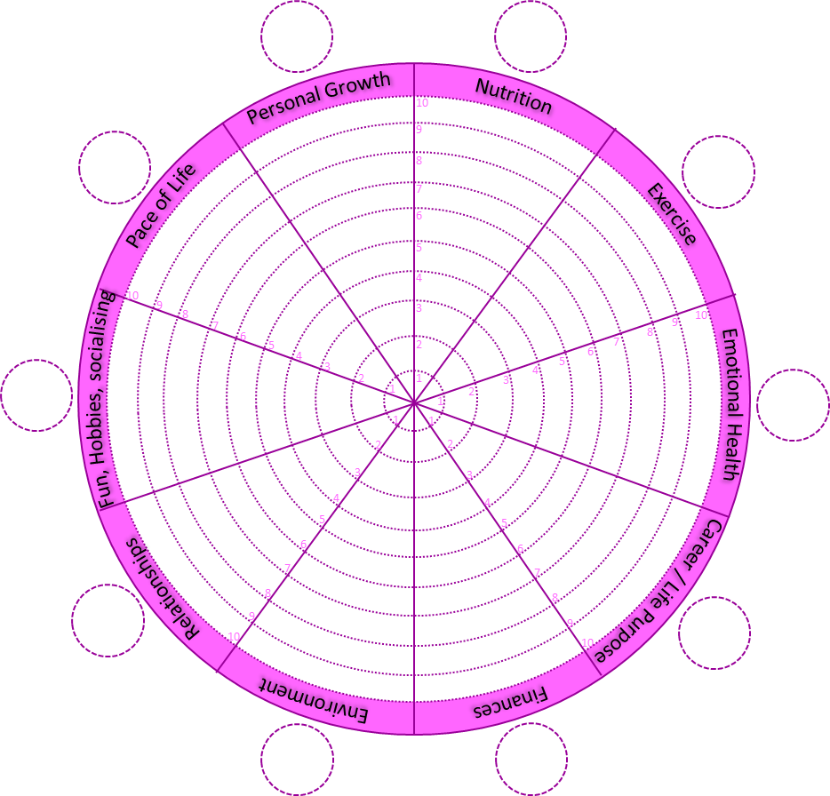

Here is an example of how that might look:

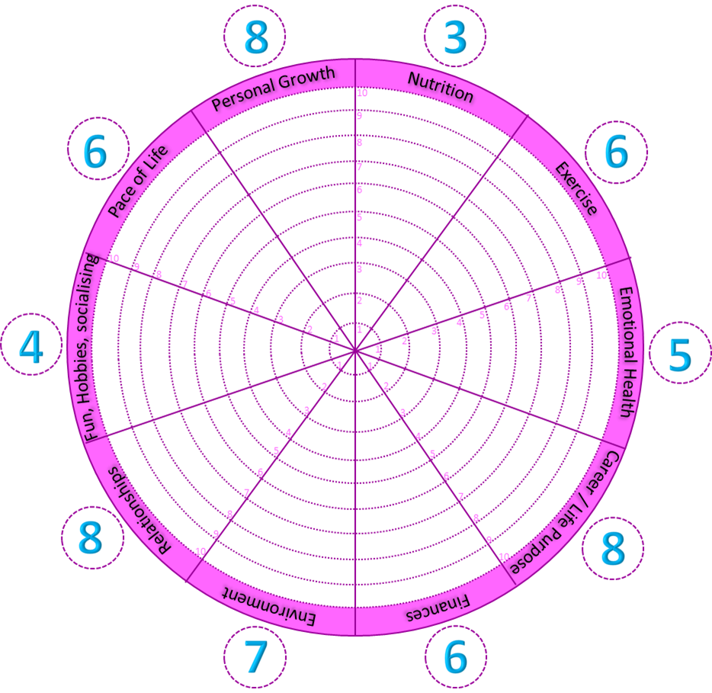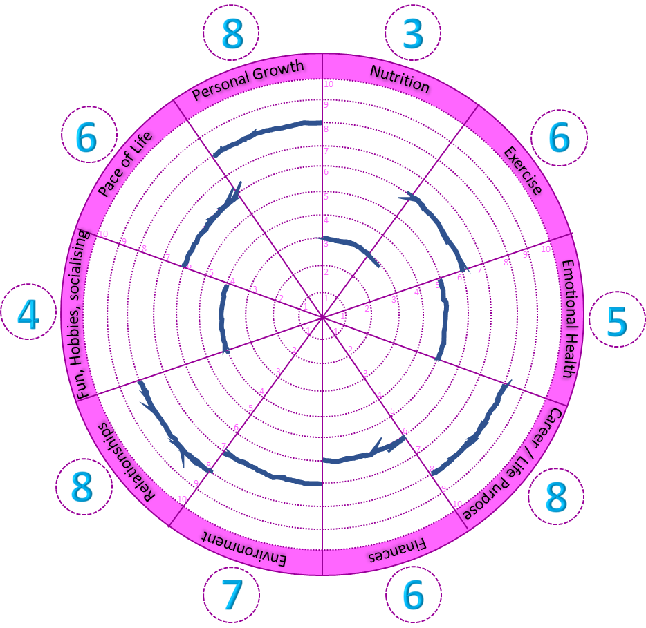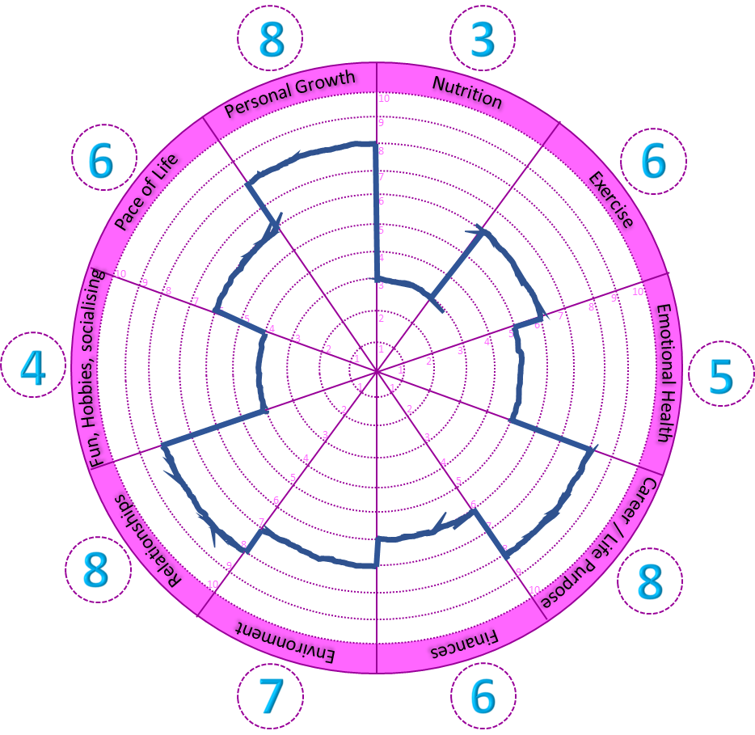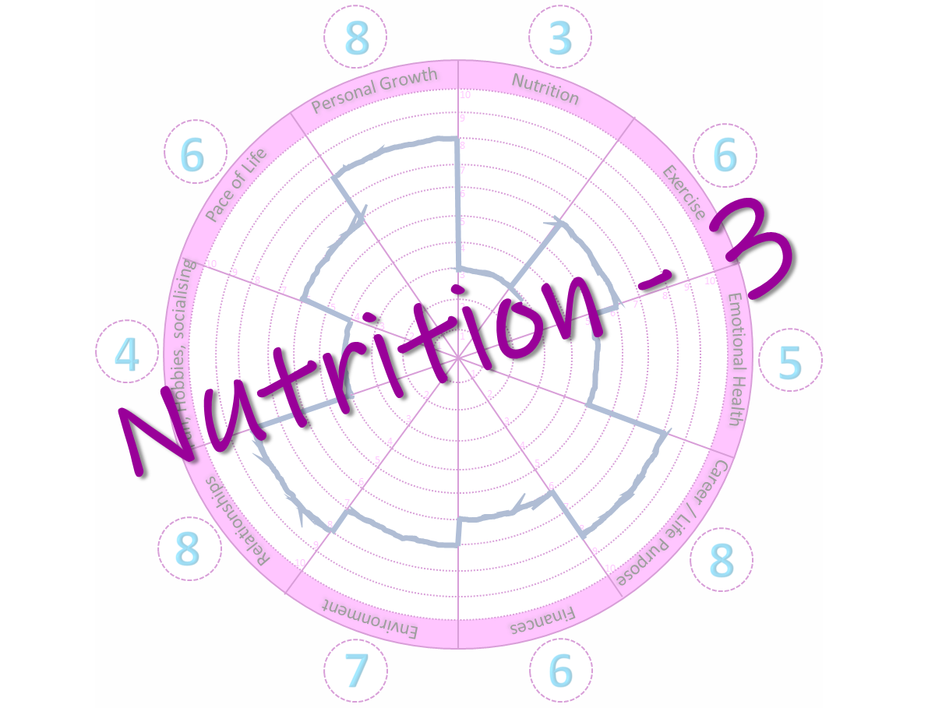

Now you’ve chosen the area you want to focus on, explore a little what it’s like right now, and what you want it to be like, then choose an action to commit to that will bring you more fulfilment in this area:



Descriptions of each area:

|  |  |
| --- | --- |
| Nutrition | What you tend to eat and whether you are happy with that |
| Exercise | What type of exercise you take, and how frequently |
| Emotional Health | How well you feel you are in touch with your emotions and whether you are happy with how your emotions manifest on a day to day basis |
| Career / Life Purpose | Your work-life or any other purpose that gives your life meaning – this might be volunteering, raising children or having a spiritual life |
| Finances | How you manage your money |
| Environment | This might be the house you live in, or the location you live in (e.g. are you a country-type living in the big city?). How you feel about your environment can also be affected by things like clutter or disrepair. |
| Relationships | Your most important relationships – you can split this down into groups such as significant other, friends and family, and rate them separately if that is useful. |
| Fun, hobbies, socialising | How much time do you make in your life for fun and creativity? |
| Pace of Life | Literally how fast-paced or otherwise is your life. You might live life at full-speed and that might be perfect for you, or it might feel too fast, and you might want to change that. |
| Personal Growth | What do you have in your life that helps you to keep learning? This might be a hobby or an interest; or it could be reading or adventures. |